ANGLICAN PARISH OF CORNER INLET – PARISH PROFILE

October 2023
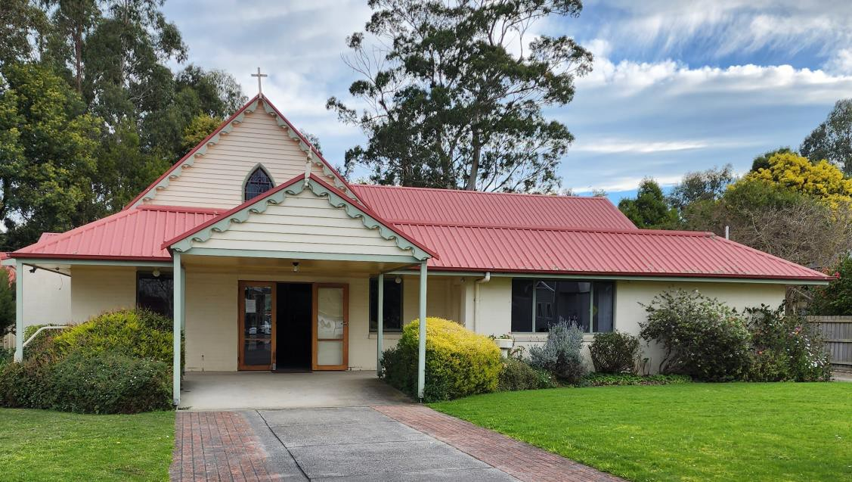

Corner Inlet Parish encompasses an area from Hedley in the East to Fish Creek in the West and along the Corner Inlet Coastline.
Walkerville, Waratah Bay, Sandy Point, Yanakie, Port Franklin and
Tidal River at Wilsons’ Promontory all fall within the Parish.

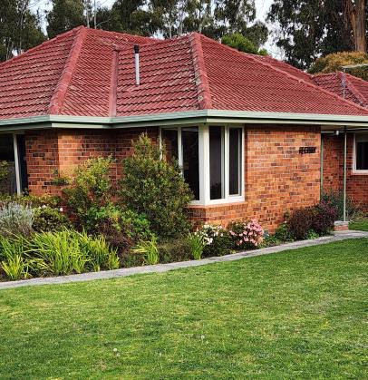
RECTORY
The Rectory is situated at 36 Station Rd Foster.
It is a brick veneer dwelling situated next to Christ Church
The dwelling consists of:- 3 bedrooms
Kitchen/family/dining area Lounge/Sitting Room Small study off lounge
Bathroom with bath, shower and toilet Toilet
Laundry
Section of Parish storage shed for Rector’s use
Substantial back garden which backs on to Stockyard Creek

PARISH CENTRES
There are 3 centres of activity: Foster, Toora and Hedley.
There are churches at Foster and Hedley and a Christian Outreach Centre at Toora

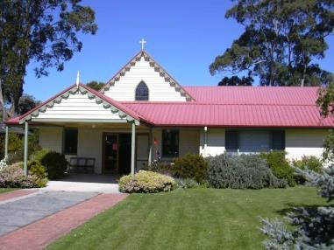
FOSTER: Christ Church is the main church building in the Parish. It has seating for approximately 120 in the church. A spacious Narthex area services the church and hall.
The Rectors Office is also situated in this area.
The attached hall is separated from the church by a moveable wall. This allows
the combined space to cater for large congregations.
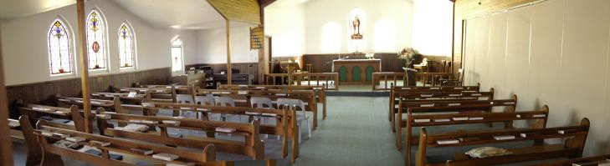
The Church Hall is approximately 150 square meters. A kitchen is attached. The Parish Office is located in this building. There are
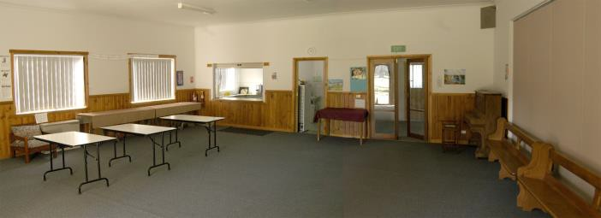
Male, Female and Disabled Toilets. Services are held each Sunday at
10.00 a.m.
The Rector officiates at these services. Lessons are read by congregation members as per a roster.
Services are usually led by a rostered Leader.
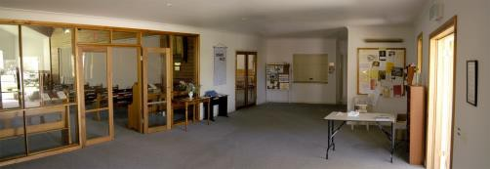
Prayers are generally led by a rostered congregation member, and there is a rostered Eucharistic Assistant each Sunday.
Two sides-people are rostered to welcome people

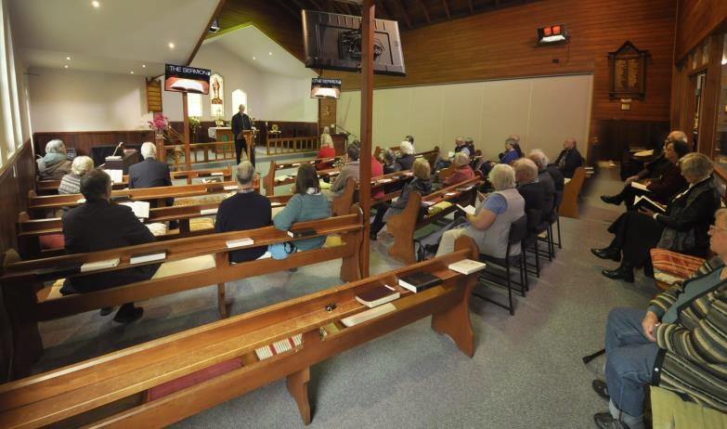
“A Prayer Book for Australia” is followed for the order of service, which is presented as a projected series of computer images on three large screens in the
Church.

Mission Praise is used for music in Foster, and the Australian Hymn Book in Hedley.
A Fortnightly service of Holy Communion is held at Prom Country House in Foster.
There is a small Clergy Discretionary A/c.
Our clergy have been encouraged to share in the wider work of the Diocese.
We have been able to supply around 100 boxes for Samaritan’s Purse
- Operation Christmas Child each year.
We have run three Alpha Courses in the town of Foster.
An annual fete was conducted in October until the coming of Covid 19 and this was an important source of income. It has currently been replaced by a series of Garage sales.
A large shed behind Christ Church houses goods donated for disposal at the fete, or garage sale.
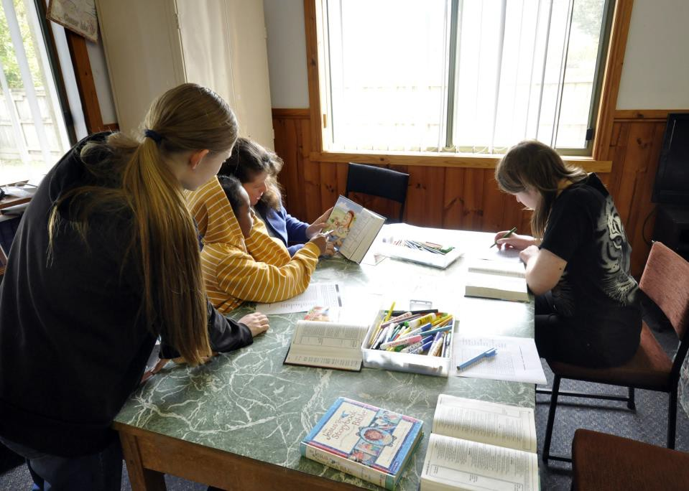
Children’s Ministry: Meets at 10.00 a.m. each Sunday at Christ Church. As required.
KYB: There are two “Know Your Bible” groups meeting in Foster on Thursday and Friday mornings at 10am.
The men’s group meets on the first, third and maybe fifth Tuesday of
each month in the hall; for prayer, discussion and Bible study.

TOORA
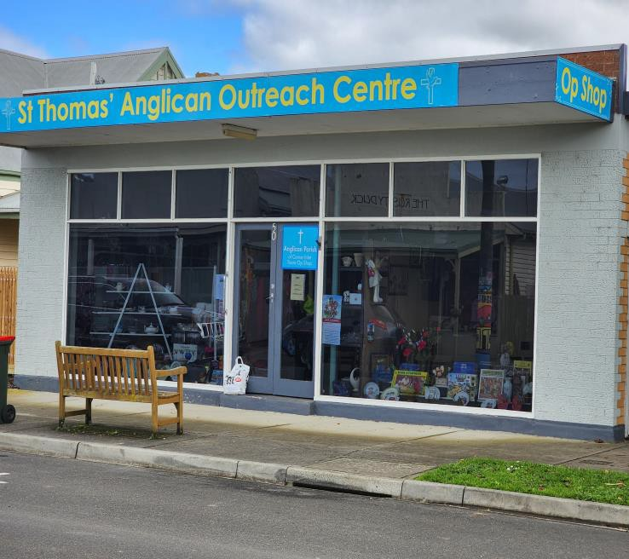
The Anglican church of St Thomas was closed and sold in 2023. There is currently no church in Toora. The Christian Outreach centre is combined with the Toora Op Shop in Stanley st.

St. Thomas’ Outreach Centre.
We are starting a drop in centre for people of the town to get together over a cuppa. Prayer and pastoral care are also offered and through this we hope to have opportunites to recommend Jesus Christ to the people of the area.

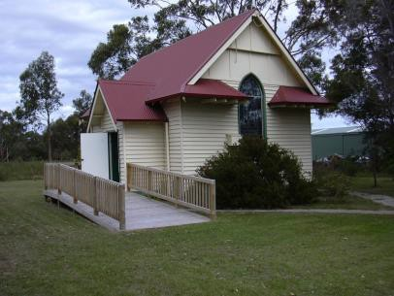
HEDLEY:
Church Of Transfiguration is a small church seating approximately 60 parishioners.
Church functions are generally held in the Hedley Hall, a few metres away from the church.
Services are held on the third Sunday of each month at 11.00 a.m.

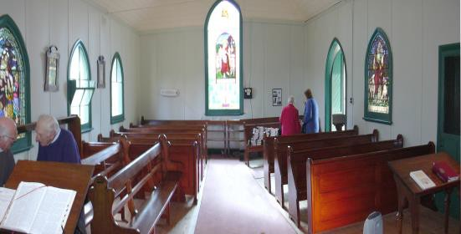
Congregation members are rostered to act as sidepeople, read the lessons and act as Eucharistic assistant.
Hedley is a district (with no town) at the Eastern end of the Parish and supports dairy, beef and sheep farming. The rainfall
in this region is considerably lower than the western end of the Parish. Hedley parishioners have traditionally taken great pride and care of their Church and have seldom drawn maintenance from the Parish.

DISTRICT INFORMATION

FOSTER.
Foster is a town of approximately 1300 people, situated in South Gippsland Shire approximately 170 km south-east of Melbourne. It services a beef and dairy cattle and sheep farming community.
The town has a Secondary College of approximately 350 students in years 7 to 12.
There is a Primary School of approximately 200 students and a Kindergarten operating 5 days per week.
There is a comprehensive Medical Centre with several resident doctors and many visiting specialists.
The town has a well-equipped hospital with surgical and midwifery facilities and an emergency department.
There are also 2 Dental Practices in the town, and various Allied Health services.
The shopping facilities include 2 supermarkets, butcher, fishmonger, greengrocer, 2 hairdressers, hardware store, cafes, restaurants, motels, hotel, Commonwealth and Bendigo Banks and numerous other shopping outlets.
There is a Library and Art Gallery.

The town is situated approximately 40km from Wilson’s Promontory and close to beautiful beaches on Corner Inlet – Waratah Bay and Sandy Point.
It is nestled at the foothills of the Strzelecki Ranges with attractions
such as Agnes Falls and Turton’s Creek close by.
The town has an 18 hole golf course, a swimming pool, football ground, netball courts, basketball stadium, gymnasium and skateboard park.
The Great Southern Rail Trail follows the former railway line and currently runs from Nyora to Port Welshpool. This is popular with walkers, cyclists and horse riders.
The area boasts many sightseeing attractions and holiday venues such as Wilsons Promontory, Agnes Falls, and Port Albert; and wonderful beaches such as Tidal River, Waratah Bay and Sandy Point. The town also has a well-supported football club – the Foster Tigers, with teams, from the 1st’s to the 4th’s.
There is also a netball club, soccer club, tennis club, basketball club, bowls club and cricket club.
There are Rotary, Probus, CWA, Scouts and Senior Citizens Clubs in the Town.
There is a very active Theatre Company, a choir and two dance schools operating in the town.
The Local Newspaper is “The Mirror” which is published weekly. It
publishes church service times, news and notes.

TOORA.
Toora is a small town with a population of approximately 700 people. All the necessary services are well catered for in Toora. Majestic (and somewhat controversial) wind generators operate along the ridge behind the town and these can be seen from the main shopping center. The town has a Primary School and Kindergarten. One of the districts most popular hotels, a motel and several small businesses including the Anglican Opportunity shop. It was once the home to Bonlac Milk industries, but they are no longer operational in the town. The town population consists of many retired people and is becoming an important tourist center with a popular caravan park.
The Swimming pool is well known, with a small but vibrant Swimming club and Aerobics sessions.

SANDY POINT.
Population approximately 230.
Sandy point is a popular beachside resort. It has excellent fishing and surfing facilities and is a very popular windsurfing area and is regularly used in attempts on the world speed sailing records. The main surf beach stretches from Walkerville in the west to Shallow inlet entrance in the east. There is a Foodland shop, takeaway, Real Estate Offices, caravan park, Surf Lifesaving club house. Services are more active during summer months to cater for the large influx of holiday makers.

FISH CREEK.
Population approximately 200
Fish creek is the gateway to Wilsons Promontory and enjoys a large tourist throughput. It is a high rainfall dairying and beef fattening area. There is a Primary School, kindergarten, Hotel Motel, hardware shop, camping shop, nursery, supermarket, numerous cafes, service station garage, dentist, art shops. The rail trail passes through the town and is well used.

WELSHPOOL.
Welshpool is a small town with a Primary School, kindergarten, Hotel, Motel, Caravan park, and several small businesses. The Anglican church at Welshpool was closed and sold off some years ago. There is a CRC church next to the school.
The fishing village of Port Welshpool is 5 kilometers to the south.

Profile for a priest

The parishioners of Corner Inlet need a priest and pastor who will guide this small, but faithful flock. Someone who is committed to the truth of God, who believes in the authority of the Holy Scriptures and is committed to the care and encouragement of the people. This priest needs to be able to teach and lead and love the people of this parish in Jesus name.

At a recent Parish council meeting the following responses were given to a word to describe the Parish of Corner Inlet.
Friendly, complacent, family, aging, conservative, generous, warm, caring, approachable, welcoming, inventive, loving, inventive, Spirit filled.

Valued aspects of past ministry were described as
Focus on exposition of the Bible, faithfulness, a delight in and care for Children, outreach in the Community, support in all kinds of situations, wonderful sermons, encouragement, equanimity, a people person,

Members expressed things that they might like to see in future in the Parish?
Participation by young people, growth in outreach ministry, development of home groups, Children’s ministry, Alpha, Collaboration with community groups, Ecumenical growth,
church social events that bring in people from outside the church, involve fringe persons, Opportunity for ministers from outside to preach.

Individual responses when asked the kind of leadership style would we like to have?
Supportive, Evangelical, follows the Anglican Prayer Book, has respect in and for worship, not happy/clappy, At ease with different liturgical services, challenging, Transformational individual, change agent, teacher, Christ Centred Leader, a GP rather than a specialist, Prayerful, Humble.

The members of the Parish are in general conservative in outlook. There is predominantly a population that is aging but which would like to be attractive to younger families. The outlook is hopeful, faithful, humble and committed to Christ and the purpose of Church.

